4.3 Double Integrals in Polar Coordinates

Recall: The identities that link the polar coordinates of a point to the rectangular coordinates of the same point are , , and .

A polar rectangle is a region of the form . A picture of a polar rectangle is (the actual rectangle is outlined in green):

Motivating Question: In this section, our first concern will be trying to find a way to find the signed volume of a solid bounded by some function and a polar rectangle. Mathematically, we wish to compute where is a polar rectangle and is continuous.

In actuality the above picture would have many more red lines and many more small polar rectangles.

In order to approximate we will add up the volume of prisms which have bases that are polar rectangles and heights given by the function . The idea is that our approximation will approach perfection as both m and n approach infinity.

To find the volume of such prisms we need to find a formula for the area of .
If we let be the area of then

We know we need to pick a sample point in to plug into in order to get our height.

This means that our approximation becomes:

As we let m and n approach infinity this approximation approaches perfection (one would have to prove that this idea that we used for rectangles also holds for polar rectangles).

The following result summarizes the above derivation.

Change to Polar Coordinates in a Double Integral Over a Polar Rectangle):
If is continuous on a polar rectangle R given by , where , then .

Example 1: Find the volume of the solid that is under the hemisphere given by and above the region bounded by and .

Example 2: Setup, but do not evaluate, an iterated integral which represents the volume of the solid bounded by the plane and the surface in the first octant.

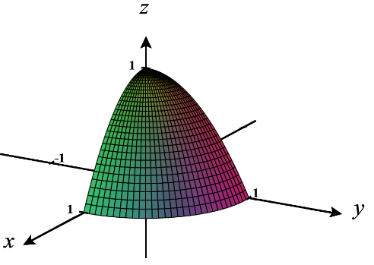

One is able to generalize the above result, (with a method similar to how we generalized from rectangles to type 1 and type 2 regions in 4.2) and obtain the following theorem. If it is the case that r can be bounded by two functions rather than two constants we can update the pervious formula to the following.

Theorem (Change to Polar Coordinates in a Double Integral Over a Non-Rectangular Polar Region):
If is continuous on a polar region of the form , then .

Note: A subtle point here is that two distinct points in D should not be in the same spot on the plane, if we are thinking of the double integral as giving a signed volume.

Note: would yield the area of the polar region D.

Note: It is possible to deduce the formula learned for polar integrals in calculus II from this theorem! Think about how this would be done.

Example 3: Use a double integral to find the area of one loop of the rose given by .

A picture of the rose (with one shaded leaf) is:
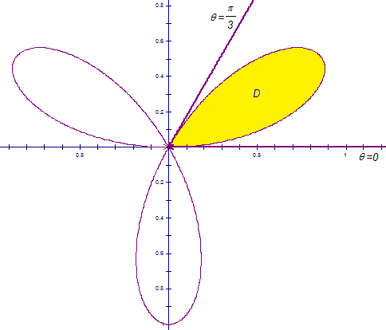

The next example is one of my most favorite math problems of all time. Those of you who may have taken me for Calculus II are aware of the awesomeness that is this next problem!
Example 4: Evaluate the following improper integral: .

This particular improper integral is quite difficult to evaluate because does not have an antiderivative which can be represented with elementary functions. However, in Calculus II we can prove that converges (we just have no idea what it converges to).

